**SECURE CODING LAB - 4**

**COMMANDS IN COMMAND PROMPT**

**NAME : SREENIDHI GANACHARI**

**REGISTRATION NUMBER : 19BCE7230**

**SLOT : L -39+40**

1) Sigverif command - Verify the integrity of a system is to make sure that all the system files are digitally signed.

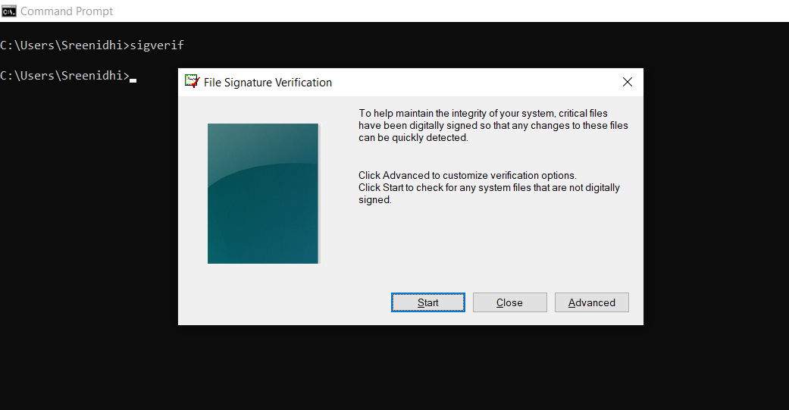

2) SC command - SC is used to communicate with SCM

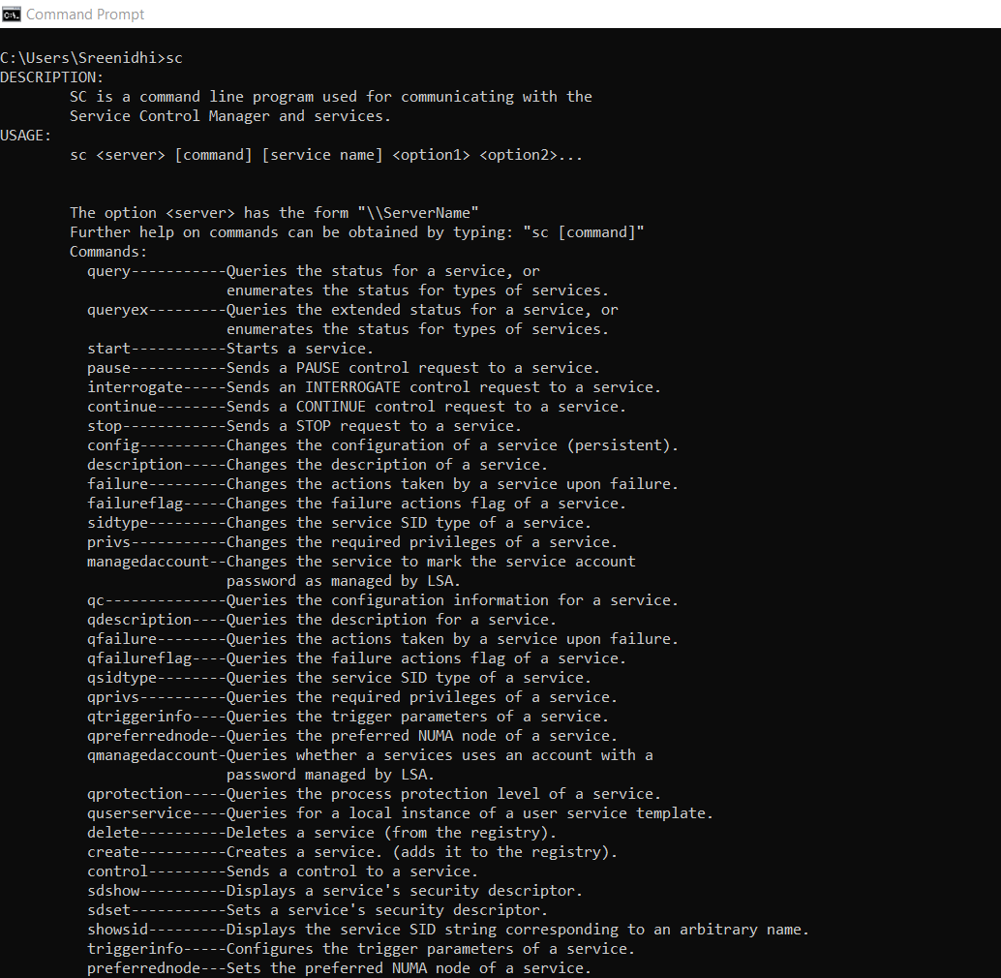

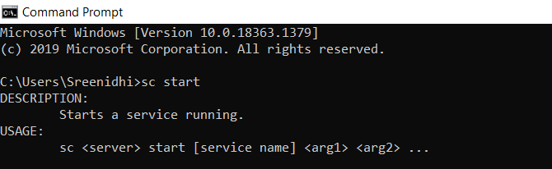

3) Volume command - Displays the volume information about the designated drive.

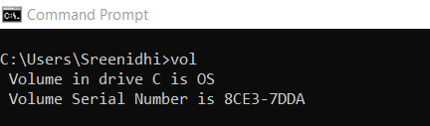

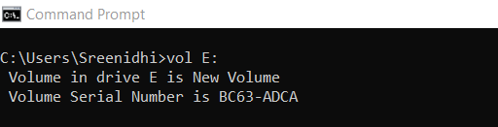

4) Assoc - Display or change the association between a file extension and a fileType.

Assoc.bmp – Displays the extension for pictures and paint .

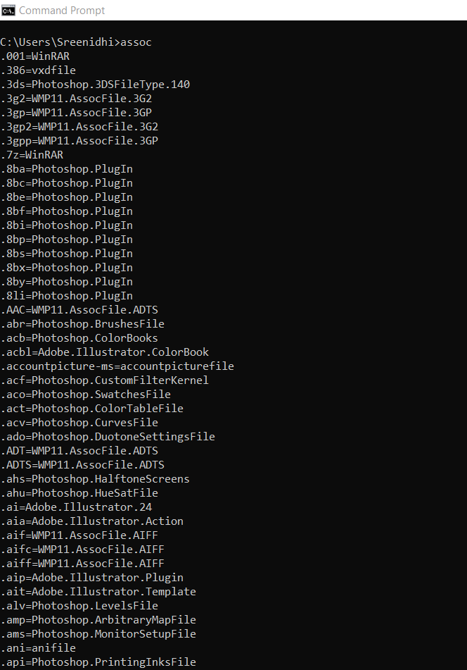

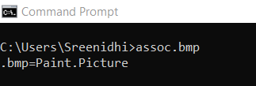

5) Driverquery -v - Improperly configured or missing drivers can cause all sorts of trouble, so its good to have access to a list of what’s on your PC.

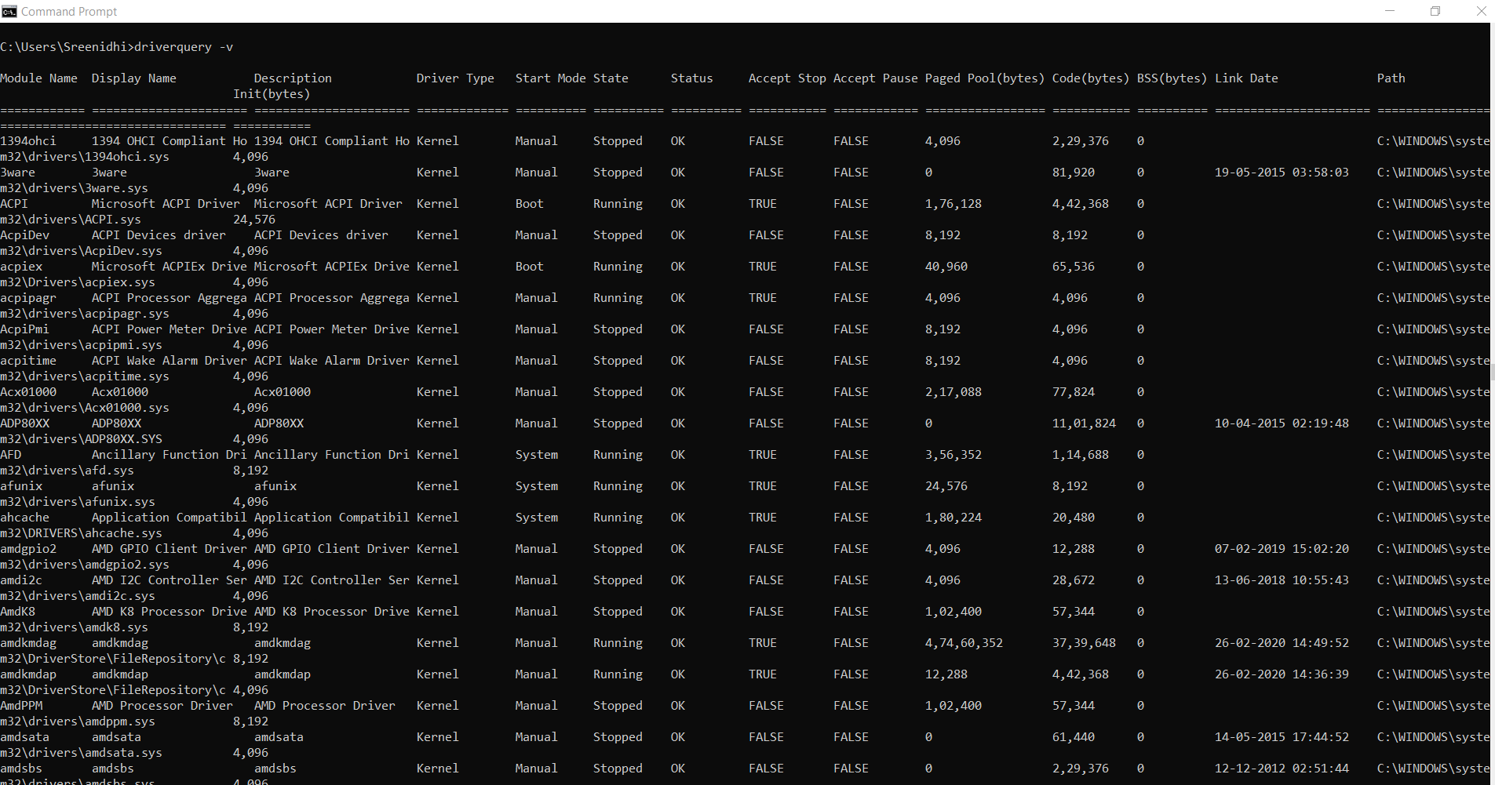

6) FileCompare - This command can be used to identify differences in text between two files, and is particularly useful for writers and programmers trying to find small changes between two versions of a file.

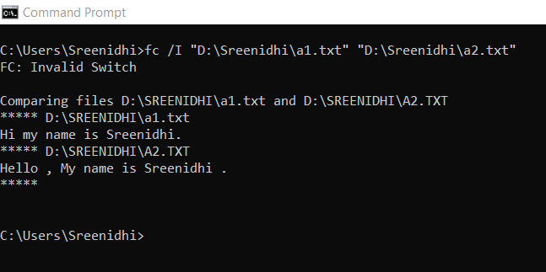

7)powercg/a - Reports the sleep states available on the computer. Attempts to report reasons why sleep states are unavailable.

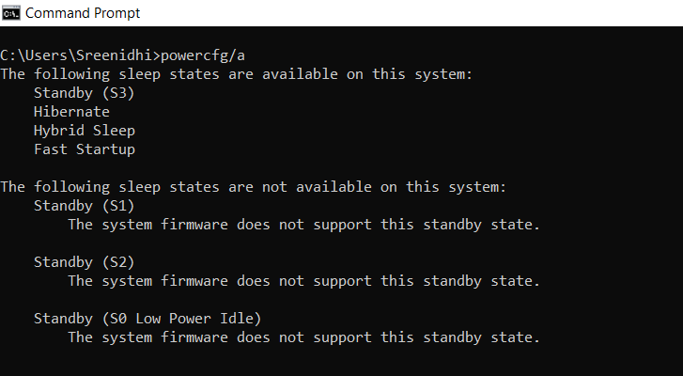

8) Rmdir – Removes an empty directory

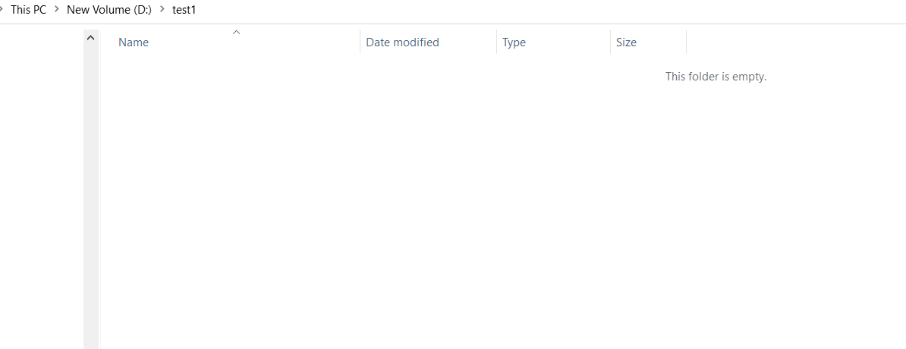

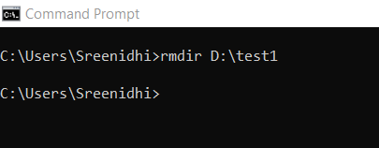

The folder has been removed.

9) Where command - Displays the location of files that match the search pattern

